

National University of Computer and Emerging Sciences
Fast Nuces
Assignment 02
The Bookstore Intelligence Mission
Web Scrapping with Python

Course: Business Data and Text Mining
Submitted by: Fatima Ikram
Roll No. 23I-5003
Date: 17th october 2026

Github: https://github.com/fatimaikram19/bookstore-scraper

1. Introduction
For this assignment I built a Python scraper using requests, BeautifulSoup and pandas. It collects data from the practice website books.toscrape.com. The scraper reads every catalogue page and collects the title, price, rating, availability and product link of each book. Everything is saved in a file called competitor_books.csv. In total the scraper collected 1000 books from 50 pages.
2. Mission 1: Reconnaissance
I inspected one book on the website and found that every book sits inside an article tag with the class product_pod. This is what I found for each piece of data.
Data Needed | HTML Tag / Class | Notes
Book Title | h3 > a | The full title is in the title attribute because the visible text is cut short
Price | p, class price_color | The text includes the pound sign, so I take out only the number
Rating | p, class star-rating | The rating word (One to Five) is the second class name
Availability | p, class instock availability | Extra spaces are removed using strip()
3. How the Scraper Works
I wrote one function called scrape_page that collects all the books from a single page. A while loop then calls this function for page 1, page 2, page 3 and so on, until the website has no more pages. This way I did not copy the same code again and again. The ratings are stored as words on the website, so I used a dictionary to change One to Five into the numbers 1 to 5. At the end all records are put into a pandas DataFrame and saved as competitor_books.csv.
4. Mission 4: Intelligence Analysis Answers
1. The most expensive book is The Perfect Play (Play by Play #1) at £59.99.
2. The cheapest book is An Abundance of Katherines at £10.00.
3. The average book price is £35.07.
4. There are 196 books with a 5 star rating.
5. 100 percent of the scraped books are in stock.
6. The top 5 highest rated books are all 5 star books. Many books have 5 stars, so I sorted them by lowest price to pick the top 5.
Title | Price | Rating
An Abundance of Katherines | £10.00 | 5
Greek Mythic History | £10.23 | 5
The Power Greens Cookbook: 140 Delicious Superfood Recipes | £11.05 | 5
Dear Mr. Knightley | £11.21 | 5
The Darkest Corners | £11.33 | 5
7. The cheapest 5 star book is An Abundance of Katherines at £10.00.
5. CEO £100 Challenge
The goal was to choose books that give the highest total star rating without spending more than £100. My program checked all possible combinations of books under £100 and picked the best one. These are the selected books.
Title | Price | Rating
Old School (Diary of a Wimpy Kid #10) | £11.83 | 5
Greek Mythic History | £10.23 | 5
Dear Mr. Knightley | £11.21 | 5
The Origin of Species | £10.01 | 4
Naturally Lean: 125 Nourishing Gluten-Free, Plant-Based Recipes--All Under 300 Calories | £11.38 | 5
The Power Greens Cookbook: 140 Delicious Superfood Recipes | £11.05 | 5
The Darkest Corners | £11.33 | 5
An Abundance of Katherines | £10.00 | 5
Fruits Basket, Vol. 2 (Fruits Basket #2) | £11.64 | 5
Total cost: £98.68
Total rating score: 44
6. Bonus Work
I scraped all 50 pages of the website instead of only 3 or 5 pages. I also added the product page link of every book to the dataset. The number of books at each star level is: 1 star has 226 books, 2 star has 196 books, 3 star has 203 books, 4 star has 179 books and 5 star has 196 books. The bar chart below shows these counts.
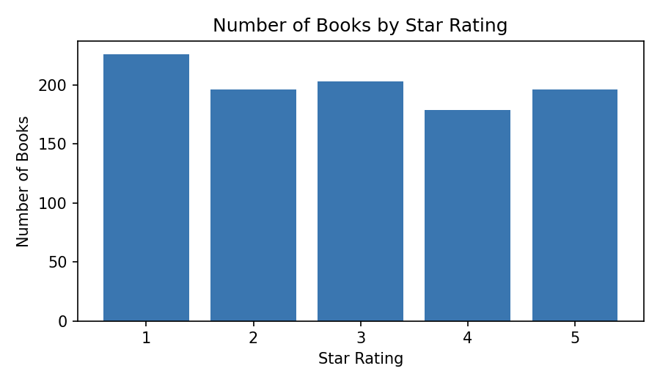
7. Business Recommendation
I would prioritise 5 star books because there are 196 of them and they cost about the same as other books. The average price of a 5 star book is £35.37 while the average price of all books is £35.07, so a high rating does not mean a higher price. Also, 100 percent of the books are in stock, and the cheap 5 star books priced around £10 to £11 can attract new customers.

